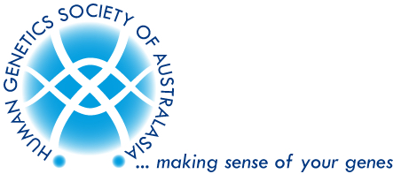
Human Genetics Society of Australasia,
NSW/ACT Branch
2026 HGSA Annual Scientific Meeting
Registration Award

We are pleased to announce that up to EIGHT Awards of early bird registration fees will be awarded to assist HGSA NSW/ACT members in attending the 2026 HGSA Annual Scientific Meeting in Christchurch, NZ (1st - 4th August 2026).

All financial members of the HGSA NSW/ACT Branch who have submitted an abstract as the presenting author (e.g. poster or oral presentation) are eligible to apply.

To apply for the Award, please provide the following:

1. A 2-page Curriculum Vitae.
2. A completed application form and copy of the submitted abstract for the Annual Scientific Meeting.
3. A statement outlining the benefit you will gain from attending the Annual Scientific Meeting and any contributions to the HGSA (maximum of 200 words).

Please forward your application & any queries via email to secretariat@hgsa.org.au

Applications close at 5 pm on Friday 22nd May 2026.

A shortlist of applicants may be invited to make a brief oral slide presentation at the NSW/ACT Branch Meeting, held in hybrid format (both in-person and online) in June (date to be decided).

